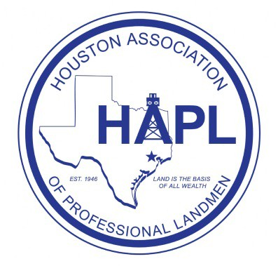

Sponsor the 2015 Shale Play Seminar and Social!

Thursday, October 15th, 2015

**** ALL SHALE PLAYS ****
(Permian Basin Shales, Eagle Ford, Bakken, Niobrara, Marcellus, Haynesville, Fayetteville, Barnett, Woodford and more)

The Houston Association of Professional Landmen (HAPL) Shale Play Seminar and the Shale Play Social will be held Thursday, October 15th, 2015 in Highland Village, on the second floor of Smith and Wollensky, 4007 Westheimer Rd., Houston, Texas, 77027. The social is an informal networking event in Houston dedicated to those individuals and companies that work in or have an interest in shale plays. The HAPL Shale Play Social proved to be a very successful networking event for shale players last year - there were hundreds in attendance! This event is only made possible by our generous sponsors. Our goal is to make this year’s HAPL Shale Play Social an even greater networking success.

We recognize the drastic effect the downturn in the market has taken on our city and fellow landmen. We have therefore lowered the price of the Seminar and sponsor levels this year. Sponsorships are greatly appreciated at any level. We have also added a new sponsor level of individual landmen for those landmen that wish to donate. The sponsorship money not only funds the social and door prizes. The sponsorship money is also used to help fund the HAPL with yearly donations to multiple charities in Houston.

We are currently looking for sponsors. The Shale Play Seminar and the Shale Play Social committees work together and pool our fundraising. If your organization is interested in being a sponsor for these events, please contact Jonathan Click (see next page). Your company will be recognized prominently with signage at t he seminar and the social in addition to applicable sponsor level benefits described below:

Sponsor Levels:

Platinum Level Sponsor - $1,000+
All the benefits of Gold Sponsorship AND the ability to provide company gift items and/or a reasonably sized company banner to display at the social.

Gold Level Sponsor - $750+
Recognition at the events on the sponsor poster AND in the Newsletter.

Silver Level Sponsor - $500+
Recognition at the events on the sponsor poster AND in the Newsletter.

Bronze Level Sponsor - $250+
Recognition at the events on the sponsor poster.

Landman Level Sponsor - $100+
Individual Landman recognition at the events on the sponsor poster.

Page 1 of 2

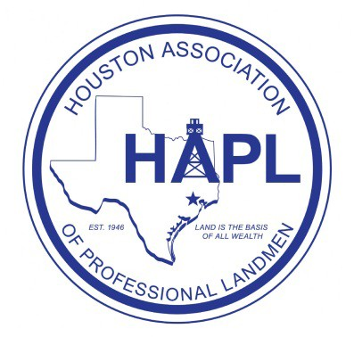

COMPLETE AND RETURN:

Thank you in advance for helping us to continue to make this event one of HAPL's premier socials.
We look forward to seeing you there!

2015 Shale Play Seminar and Social Sponsor Form

Please complete and email this form to a Chairman. Include a copy if you pay by check.

Name of Business/Organization:

Contact Name:
Phone:

Address:

Email:

Requested Sponsor Level (first come, first served):

Comments:

Make checks payable to “HAPL” and write “Shale Play” and your chosen Sponsor Level in the Memo section. Mail your check to HAPL at 800 Bering Drive, Suite 120, Houston, Texas 77057
Be sure to email your company’s name/Logo as you would like it to appear on the sponsor board to Jonathan Click NO LATER THAN October 1st, 2015.

Jonathan Click, CPL Allyson Johnstone, CPL

Shale Play Seminar Chairman & Social Co-Chairman Shale Play Social Co-Chairman
Jonathanclick@gmail.com Allysonjohnstonecpl@gmail.com
832-725-9910 512-619-1358
Page 2 of 2

